Step 1:
- Download the cover letter & application to extend the time to file an objection.
- Add your name in the signature field at the bottom of the cover letter, on page 1.
- Add (i) your name and (ii) the date of the Notice of Assessment, in the appropriate fields on the application to extend the time, on page 2.
- Print
Step 2:
- Download the notice of objection form pre-populated.

- Save a copy of the notice of objection to your computer.

- Open the copy on your computer using Adobe Acrobat and add the following information:
a) At the top left of the form, add:  i. your first and last name;  ii. the mailing address that you use with the CRA;  iii. the telephone number at which you can be reached. | 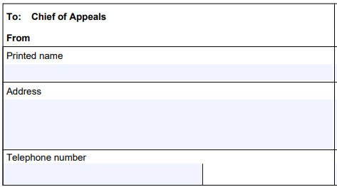
b) OPTIONAL: If you have a tax accountant or other tax representative and would like them to represent you, you can fill in the fields at on top right of the form. | 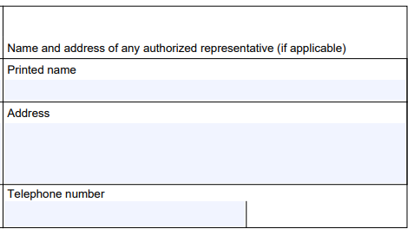
c) Complete the appropriate information below regarding 2021 Notice of Assessment:
*VERY IMPORTANT: if you received more than one Notice of Assessment for your 2021 taxation year, must object to the last notice issued.
*VERY IMPORTANT: If you properly complete the Objection form with all relevant information regarding your Notice of Assessment, you do not need to attach the Notice of Assessment to your Objection; please note, however, that in that case your Objection may be rejected if you do not provide complete and accurate information on your Notice of Assessment.
i. the date of the Notice (you will find this information in the upper right corner of the Notice; for most of the members, the notice will have been issued sometime in the year 2022); | 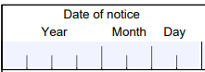
ii. the number of the Notice (you will find this information in the upper right corner of the Notice; but note that most of the notices do not have a number); | 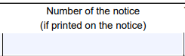
iii. the tax year, which for most of the members will be 20211231, unless you know of special circumstances that apply to your case; | 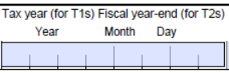
iv. your social insurance number must also be entered to ensure that the CRA can retrieve your file and make the appropriate changes to your tax year if your objection is accepted. | 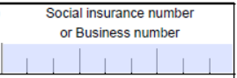
d) The section “issues, reasons and relevant facts” has already been filled. We recommend that you do not change this section.  NOTE: If you received a damages amount less than $1,500, replace the reference to $1,500 in paragraph 7 with the amount of damages you received | 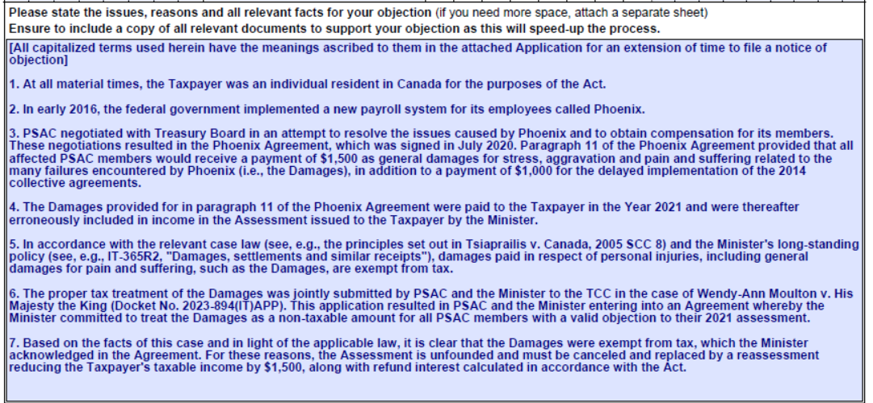
e) In the section at the bottom:
i. type your name; | 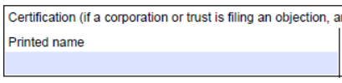
ii. add the date of your signature. | 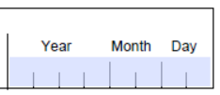
- Print  - Add your signature, by hand, at the bottom of the document  *VERY IMPORTANT: unsigned notices of objection will be refused by the CRA | 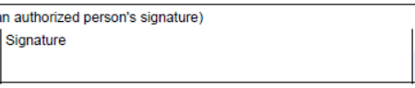
Step 3:
- Assemble the printed documents in the following order:
i. the cover letter and the application for an extension of time, duly filled (step 1);
ii. the Notice of Objection, duly filled and signed (step 2);
iii. optional: a copy of your 2021 Notice of Assessment (do not send the original; although not required if you have properly completed all relevant fields on the Objection form, we recommend that you include your Notice of Assessment with your objection if you have it available, in order to expedite the processing of your Objection).
Step 4:
- We recommend that you send your assembled objection package by registered mail to the CRA, however you also have the option of faxing it or sending it by ordinary mail.
Chief of Appeals
Appeals Intake Centre
CANADA REVENUE AGENCY
1050 Notre Dame Avenue
Sudbury ON
P3A 5C1
Fax numbers:
705-670-6649 or 1-866-443-4955
604-587-2672 or 1-866-489-6832
- Keep a copy for your records.

