Step 1:
- Download the request to extend the deadline.
- Enter (i) your name and (ii) the date of the Notice of Assessment, in the appropriate fields
- Save the properly completed request locally on your computer
Step 2:
- Access your MyAccount for Individuals
Step 3:  - Click the "File a Formal Dispute" option at the bottom of the page in the navigation area on the left | 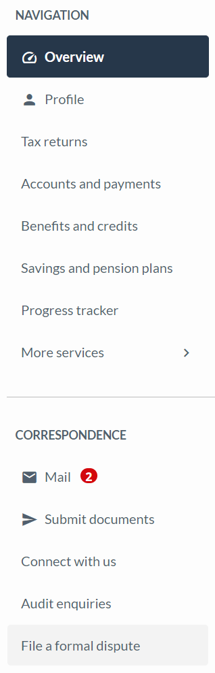
a) On the next page, click the “Start” button at the bottom. | 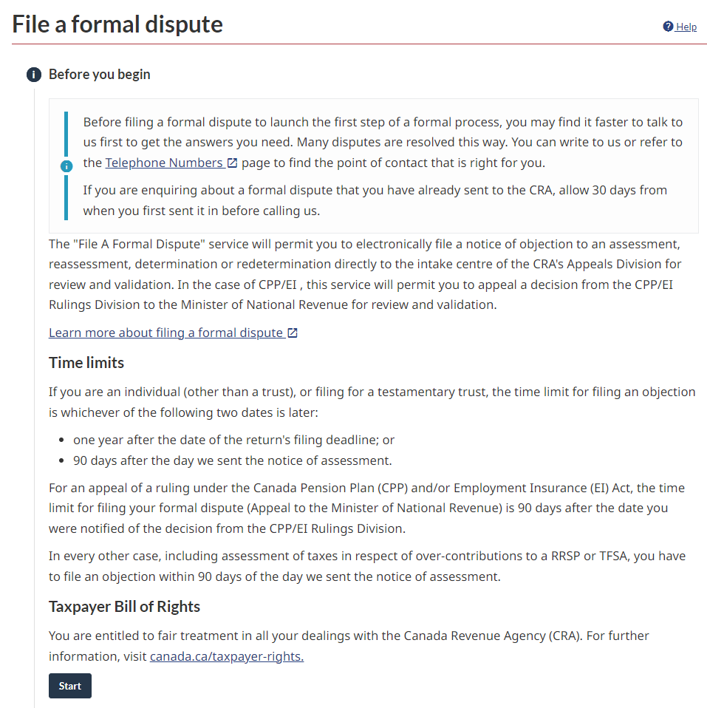
b) On the next page, scroll down the menu and select the option “Income Tax”. | 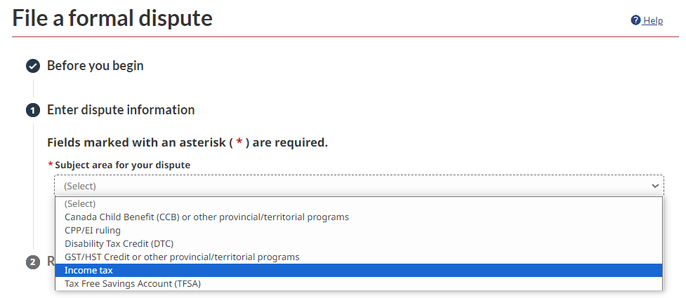
c) The following question will appear: “Are you here to provide the CRA with missing information for a tax return you have already filed with us or to submit information after an audit (re) assessment or (re)determination?”  Click “No”. | 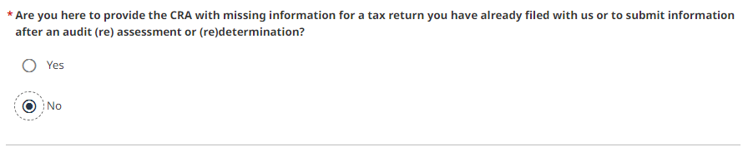
d) The following question will appear: “Did the CRA send you and income tax assessment notice for a tax year when you had not previously filed a tax return? Are you here to provide the CRA with information that may change that assessment?”  Click “No” (unless special circumstances apply to your case). | 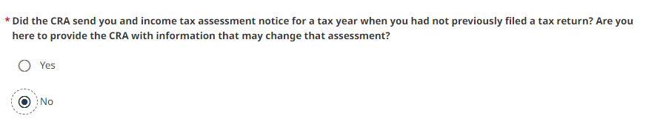
e) Scroll down the menu “Tax year/ base year printed on your notice⁠⁠⁠⁠⁠” and select “2021”. | 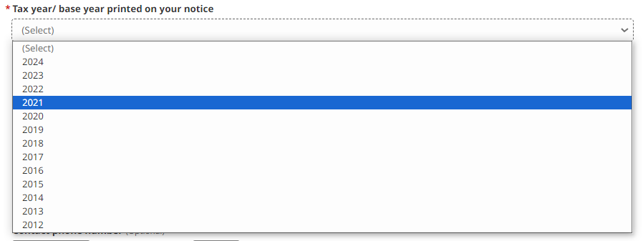
f) Complete the appropriate information regarding your 2021 Notice of Assessment:
*VERY IMPORTANT: if you received more than one Notice of Assessment for your 2021 taxation year, must object to the last notice issued
i. the number of the Notice (you will find this on the top right of the Notice; but note that most of the notices do not have a number); | 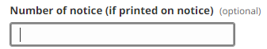
ii. the date of the Notice (you will also find it on the top right of the Notice; for most of the members, the notice will have been issued sometime in the year 2022). | 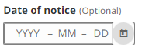
g) Add the telephone number at which you can be reached. | 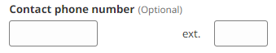
h) In the following “relevant facts and reasons” section, we recommend that you copy and paste the bolded text below in its entirety:  NOTE: If you received a damages amount less than $1,500, replace the reference to $1,500 in paragraph 7 with the amount of damages you received | 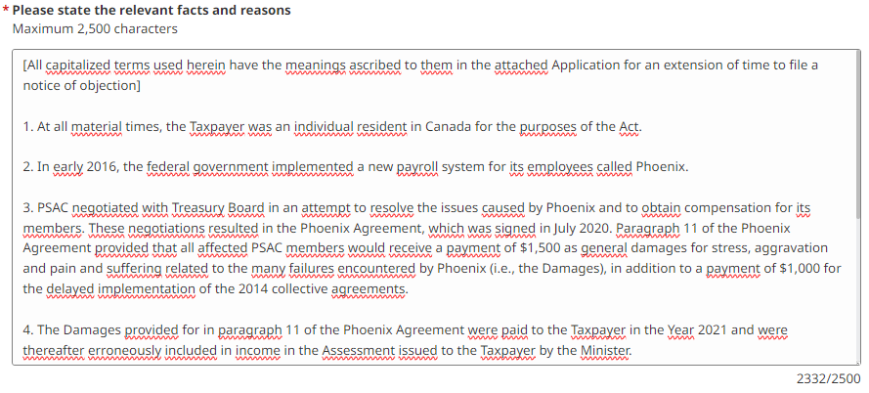
[All capitalized terms used herein have the meanings ascribed to them in the attached Application for an extension of time to file a notice of objection]

1. At all material times, the Taxpayer was an individual resident in Canada for the purposes of the Act.

2. In early 2016, the federal government implemented a new payroll system for its employees called Phoenix.

3. PSAC negotiated with Treasury Board in an attempt to resolve the issues caused by Phoenix and to obtain compensation for its members. These negotiations resulted in the Phoenix Agreement, which was signed in July 2020. Paragraph 11 of the Phoenix Agreement provided that all affected PSAC members would receive a payment of up to $1,500 as general damages for stress, aggravation and pain and suffering related to the many failures encountered by Phoenix (i.e., the Damages), in addition to a payment of up to $1,000 for the delayed implementation of the 2014 collective agreements.

4. The Damages provided for in paragraph 11 of the Phoenix Agreement were paid to the Taxpayer in the Year 2021 and were thereafter erroneously included in income in the Assessment issued to the Taxpayer by the Minister.

5. In accordance with the relevant case law (see, e.g., the principles set out in Tsiaprailis v. Canada, 2005 SCC 8) and the Minister's long-standing policy (see, e.g., IT-365R2, "Damages, settlements and similar receipts"), damages paid in respect of personal injuries, including general damages for pain and suffering, such as the Damages, are exempt from tax.

6. The proper tax treatment of the Damages was jointly submitted by PSAC and the Minister to the TCC in the case of Wendy-Ann Moulton v. His Majesty the King (Docket No. 2023-894(IT)APP). This application resulted in PSAC and the Minister entering into an Agreement whereby the Minister committed to treat the Damages as a non-taxable amount for all PSAC members with a valid objection to their 2021 assessment.

7. Based on the facts of this case and in light of the applicable law, it is clear that the Damages were exempt from tax, which the Minister acknowledged in the Agreement. For these reasons, the Assessment is unfounded and must be canceled and replaced by a reassessment reducing the Taxpayer's taxable income by $1,500, along with refund interest calculated in accordance with the Act.

i) Make sure that all fields are filled in correctly and then click “Next” at the bottom of the page | 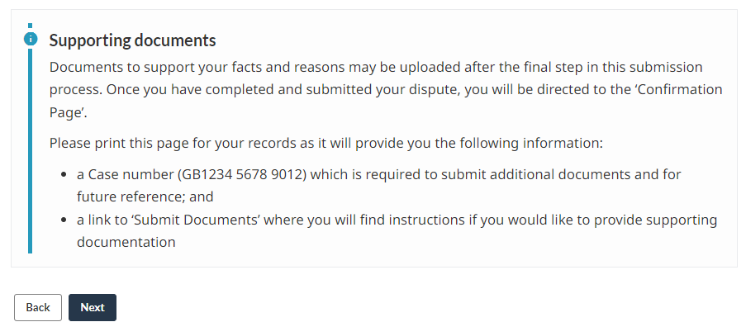
j) On the next page, you see a summary of your relevant information. If the information is correct, click “Submit”. | 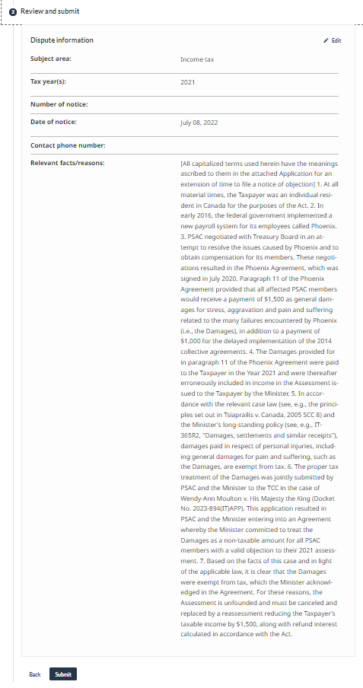
k) A confirmation page will appear with a confirmation number beginning with “GB”. Make a note of this number. | 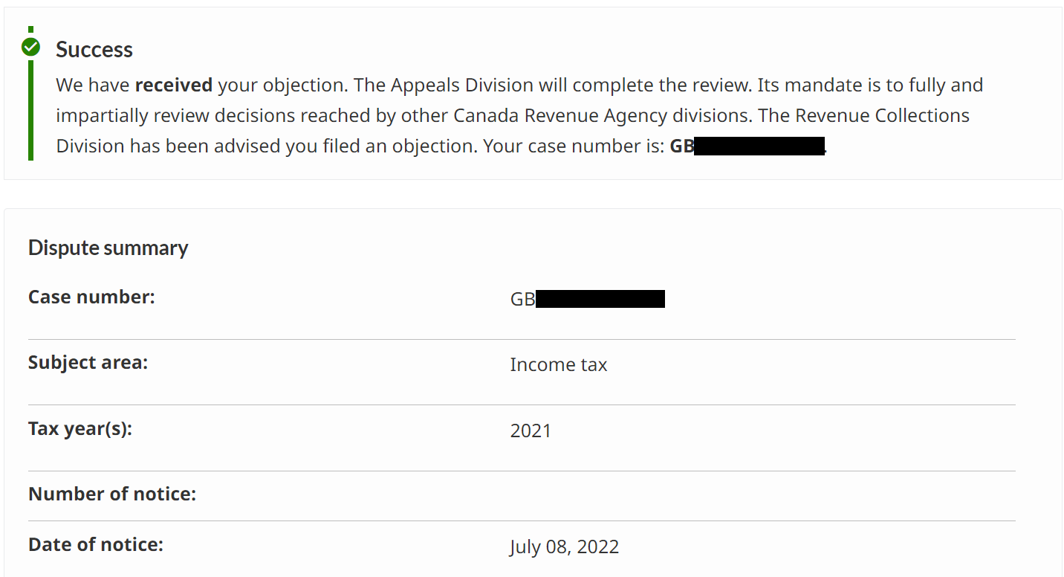
*VERY IMPORTANT: your notice of objection will be rejected by the CRA if you do not follow the following step 4 instructions until the end:  Step 4:  - Do not quit the page yet  - Go at the bottom and click on the option “Submit Documents” | 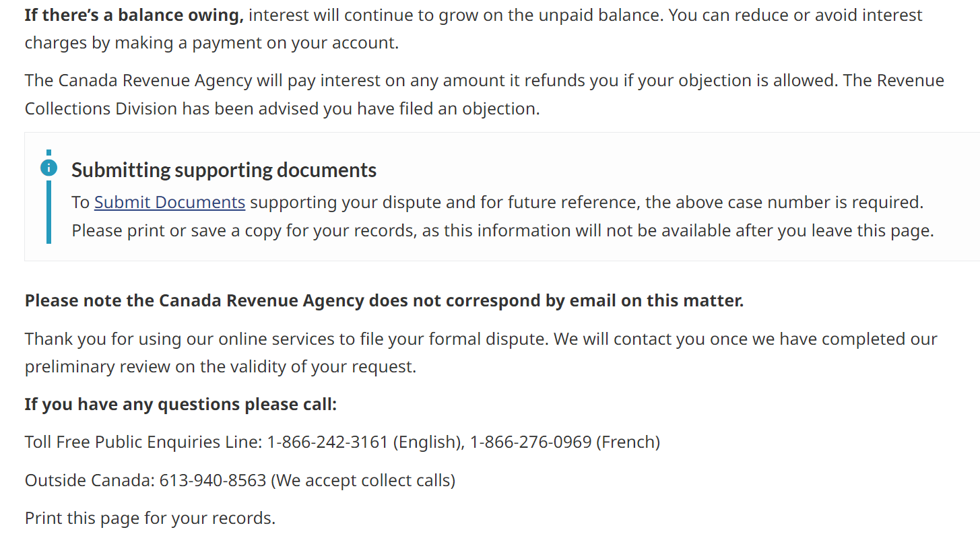
a) On the next page, click the button “Start”. | 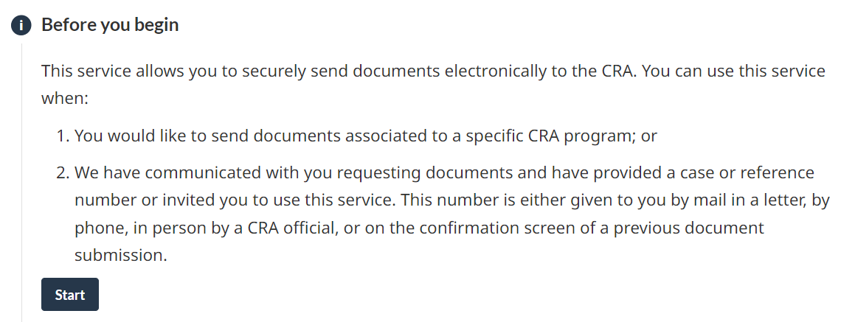
b) The following question will appear: “Do you have a case or reference number?”  Click “Yes”. | 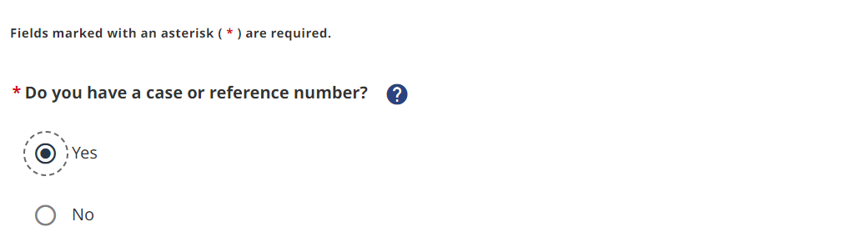
c) The following question will appear: “What does your case or reference number start with?⁠”  Scroll down the menu and choose “GB”. | 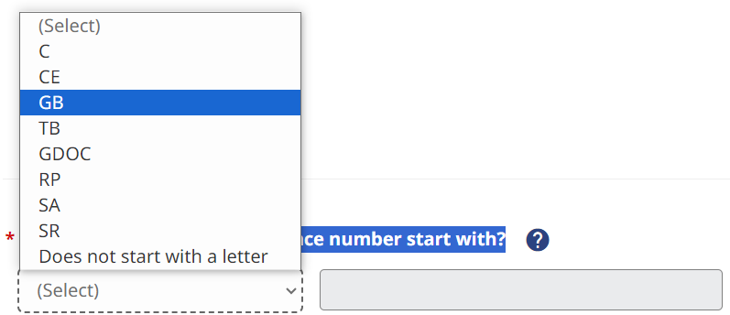
d) Enter your GB number and click “Next”.
e) On the next page, click on the button “Attachment”. An attachments window will appear. Click “Browse” and select the request to extend the deadline that you have previously completed and saved locally (step 1), then click “Open”.
f) Once the correct document is selected, we recommend that you copy and paste the following text in its entirety into the section “Provide a brief description of your document”:  This is a request for an extension of time to file a notice of objection that the taxpayer is filing with their notice of objection for the 2021 taxation year.  Then, click “Upload file(s)”. | 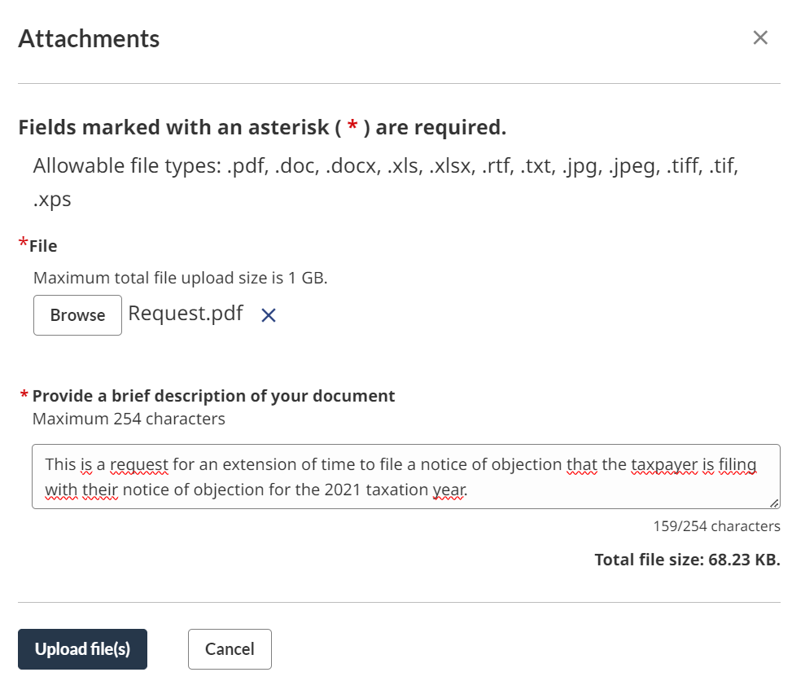
g) You will be returned to the previous page with a summary of the document. Review the information and if it is accurate, click “Next”. | 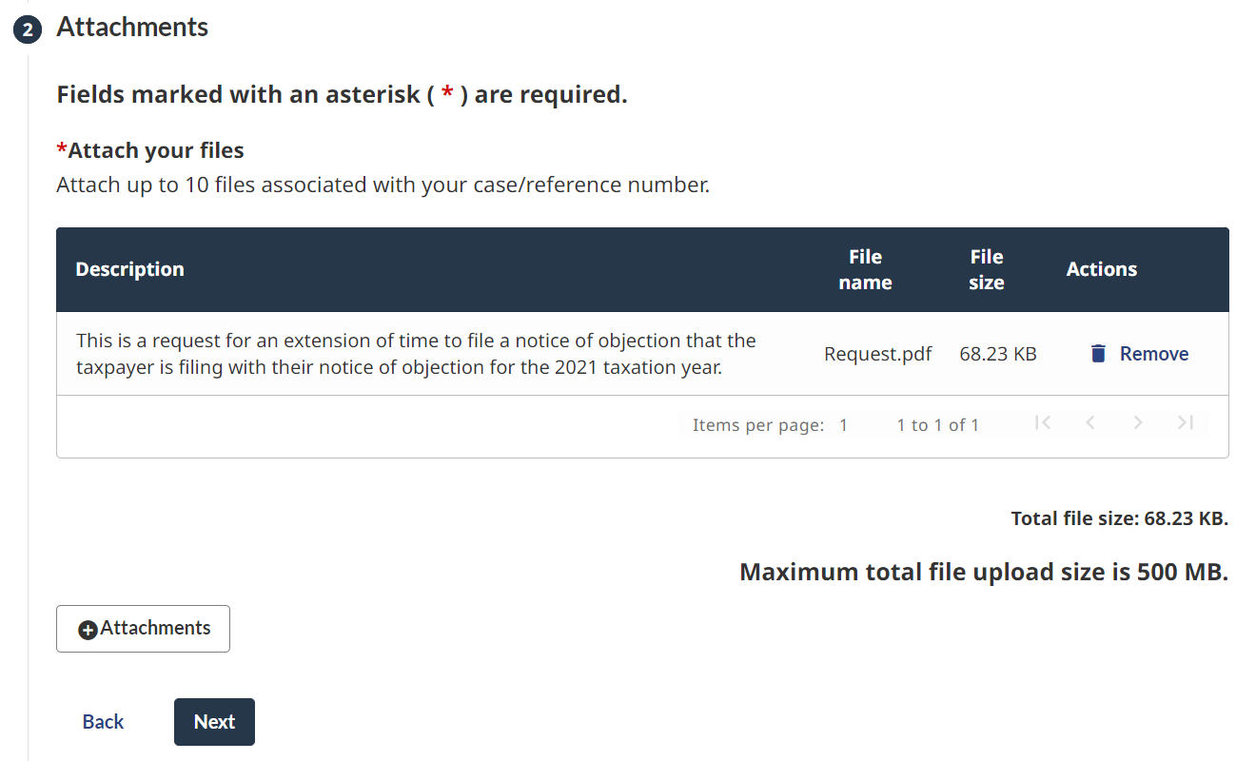
h) On the review and Submit page, click “Submit”. | 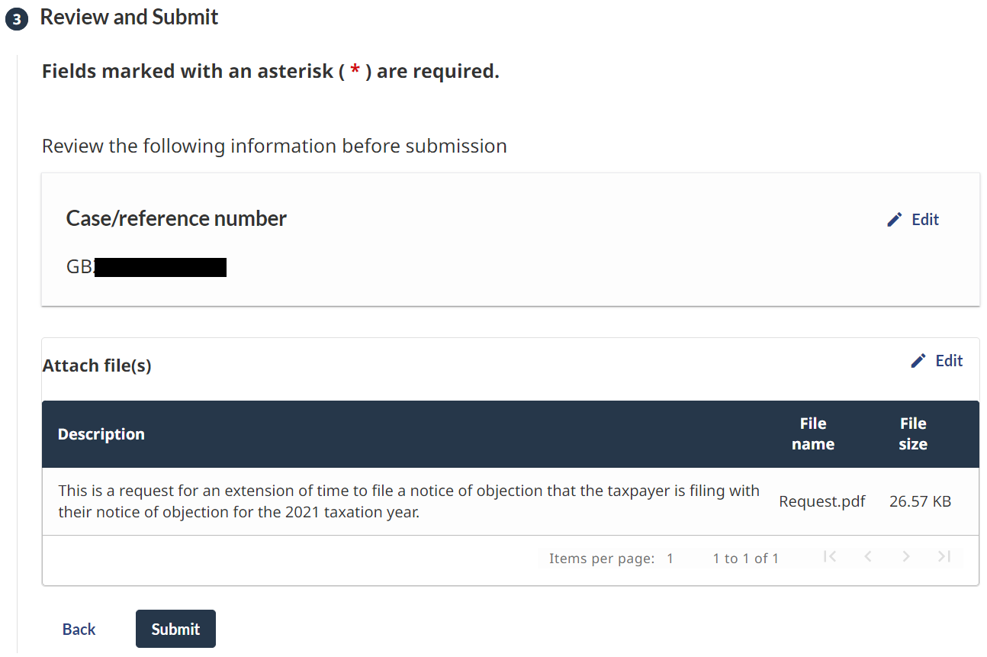
i) A confirmation page will appear. Keep a copy of the confirmation number for your records. | 