Step 1:
- Download the cover letter & application to extend the time to file an objection.
- Add your name in the signature field at the bottom of the Cover Letter, on page 1.

- Add (i) your name and (ii) the date of the Notice of Assessment, in the appropriate fields on the Application to extend the time to file an objection, on page 2.
- Print the document
Step 2 :
- Download the partially pre-populated objection form.
- Add the following information using Adobe Acrobat:
a) At the bottom of page 1 of 3, enter your Social Insurance Number (SIN) to allow Revenue Québec to identify your file.
b) At the top of page 2 of 3, enter the relevant information that concerns you in section “1. Information about the person filing the objection”:
i. greeting (“Mrs” or “Mr”), your last name and your first name;
ii. DO NOT WRITE ANYTHING in the “Name of the Corporation” field;
iii. enter your postal address known to Revenu Québec as well as your postal code; add, if you wish, one or more telephone number(s) and/or an email address in order to be more easily reachable; | 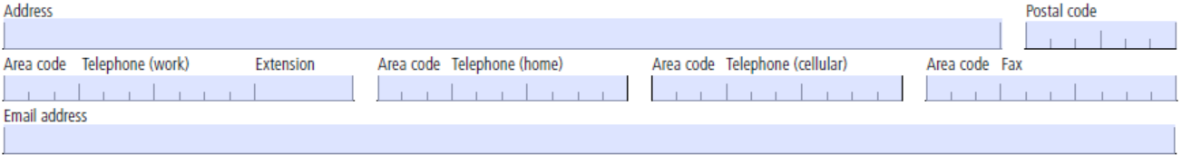
c) Complete the “2. Information about the representative” section if you wish to be represented by your accountant or anothscer representative. | 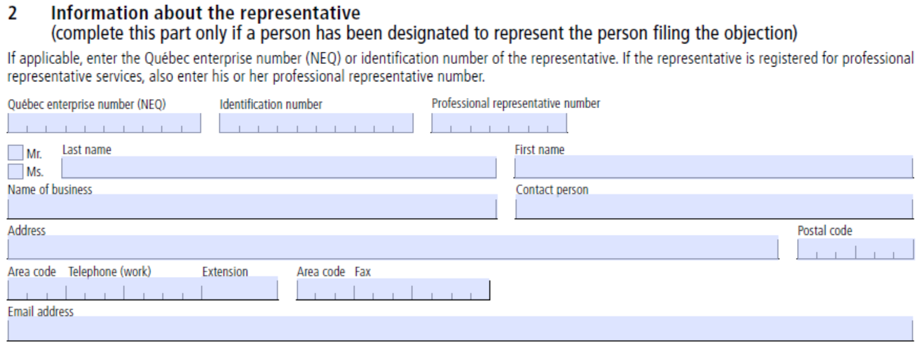
d) In section “3. Information about the disputed notices or refund applications”, enter the following information concerning your notice of assessment issued for the year 2021:
*IMPORTANT: if you received more than one Notice of Assessment for your 2021 taxation year, must object to the last notice issued.
i. the Notice Number (you will find this information in the upper right corner of the Notice; for most of the members, the notice will have been issued sometime in the year 2022); | 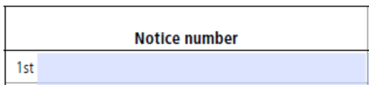
ii. the date of the Notice (you will also find this information in the upper right corner of the Notice); | 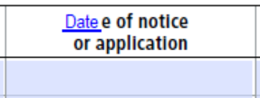
iii. the amount of Damages that you have received in 2021;  if the total amount you received was $2,500, the portion attributable to the Damages received was $1,500 (in this case, enter “1,500” in the “disputed amount” box);  if the total amount you received was less than $2,500, the portion attributable to Damages was likely less than $1,500 (in this case, enter any other amount of Damages you received in the “disputed amount” box); | 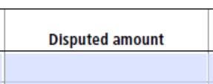
iv. lastly, enter “2021” for the relevant taxation year (unless special circumstances apply to your case). | 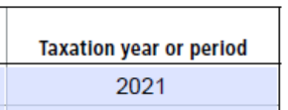
e) In the filed “List the laws to which the notice of objection applies” at the bottom of the page, indicate “Taxation Act”. | 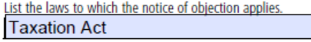
f) At the top of page 3 of 3, under section “4. Description of the objection”, write “See detailed grounds in the attached Schedule A”. | 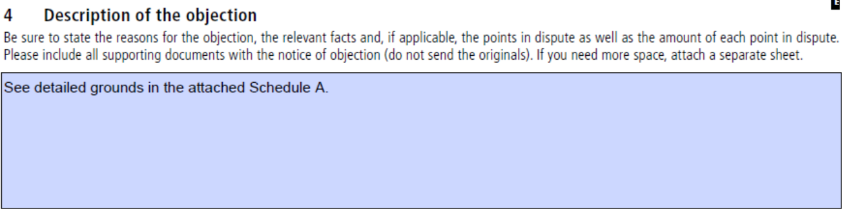
g) At the bottom of the page, add your last name and first name, and the date of your signature. | 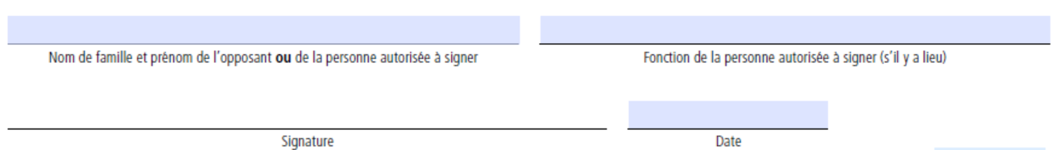
- Print the duly completed objection form
- Add your signature by hand on the signature line at the bottom of page 3
Step 3 :
- Open the document Schedule A - grounds for objection.
- In paragraph 10 on the last page, enter the amount of Compensation you received;
if the total amount you received was $2,500, the portion attributable to the Damages received was $1,500 (in this case, enter “1,500” in the “disputed amount” box);
if the total amount you received was less than $2,500, the portion attributable to Damages was likely less than $1,500 (in this case, enter any other amount of Damages you received in the “disputed amount” box);
- Print the duly completed grounds for objection.
Step 4 :
- Assemble the printed documents in the following order:
i. the cover letter & request for extension of time, duly filled (step 1);
ii. the notice of objection, duly completed and signed (step 2);
iii. the ground for objection, duly filled (step 3)
iv. a copy of your Notice of Assessment issued for the 2021 tax year (do not send the original).
*IMPORTANT : Revenu Québec requires that the Notice of Assessment be attached to the Objection. Your objection may be rejected if your Notice of Assessment is missing.
Step 5 :
- We recommend that you send your assembled objection package by registered mail to Revenu Québec. however you also have the option of faxing it or sending it by ordinary mail.
Revenu Québec
3800, rue de Marly
C. P. 25025, succursale Terminus
Québec (Québec)
G1A 0B8
Fax numbers:
418-577-5254 ou 1-866-374-7286
- Keep a copy for your records.

